Future Study Hub

Submitted By,

Preet Vachhani 202203100110096,

Manthan Sinojiya 202203100110112,

Sujal Hirpara 202203100110117,

Dharam Kathiriya 202203100110162

Guided By,

Pooja Patel

For partial fulfillment of the requirements

For the Degree of Bachelor of Computer Application

B.V. Patel Institute of Computer Science,

Uka Tarsadia University.

March, 2024.

**DECLARATION**

We hereby declare that the project titled “Future Study Hub” is fully implemented by us. It is neither paid nor copied. Even though, later on, in case of any infringement found for this project work, we are solely responsible for the same and understand that as per UGC norms, the University can revoke the degree conferred to us.

|  |  |  |
| --- | --- | --- |
| **Enrolment Number** | **Name** | **Signature** |
| 202203100110096 | Preet Vachhani |  |
| 202203100110112 | Manthan Sinojiya |  |
| 202203100110117 | Sujal Hirpara |  |
| 202203100110162 | Dharam Kathiriya |  |

Date: Place:

**Work Sufficiency Certificate**

As a guide, I assure you that the project work presented by the team is sufficient and qualitative according to the specified time duration and team size.

Guide Name: - Pooja Patel

Date: Place:

1 Project Course Awareness: - 5

1.1 Objective: - 5

2 Project Definition Selection: - 5

2.1 Definition: -. 5

2.1.1 Distinct functionality in each system: - 5

3 Proposed System Requirement Analysis: - 6

3.1 Tools and Technology: - 6

3.1.1 Tools: - 6

3.1.2 Technology: - 6

3.2 Definition: - 6

3.3 Purpose: - 6

3.4 Scope: - 6

3.5 User’s Functional requirements: - 7

3.6 Non-functional requirements: - 9

3.7 Users of the system with their characteristics: - 10

3.7.1 Number of users: - 10

4 Conceptual Diagram Design: - 11

4.1 Activity Diagram: - 14

5 System Model: - 16

5.1 Agile Model Implementation for Our Project: - 16

6 Database Design: - 18

6.1 Table with description includes attributes, data type, size, and constraints: - 18

6.2 A normal form of a database schema: - 23

6.3 Number of tables: - 23

7 User Interface Design 24

7.1 Screenshot of Homepage: - 24

7.1.1 Used navigation control with justification: -. 24

7.2 Screenshot of UI: - 25

**8 Report Design:-……………………………………………………………………………………….. 28**

8.1 TPS Report: - 28

8.2 MIS Report: - 28

8.3 Dashboard: - 28

# Project Course Awareness: -

## Objective: - The system aims to help candidates prepare for the IELTS exam by offering classes, study materials, sample questions, and practice tests, enabling them to enhance their English language skills and increase their chances of success in the exam.

# Project Definition Selection: -

## Definition: - Future Study Hub is an online educational platform that helps individuals in planning their future settlement in any country of their choice. System offers classes and provide information about countries that are good for pursuing higher education. System offers study materials, sample questions, and practice tests to help candidates prepare for each section of the IELTS exam.

### Distinct functionality in each system: -

1. **Student Visa Guidance: -** IDP offers visa assistance to students who are planning to study abroad. This includes help with applying for visas, understanding visa requirements, and navigating the visa process.
2. **Personalized counseling: -** LEAP SCHOLAR offers personalized counseling to students who are interested in studying abroad. The counseling service includes help with choosing a university, applying for scholarships, and preparing for the study abroad experience.
3. **Manage Scholarship: -**IDP offers a scholarship search engine that helps students find scholarships that they are eligible for.

# Proposed System Requirement Analysis: -

## Tools and Technology: -

### Tools: -

1. *XAMPP*
2. *VS CODE*

### Technology: -

1. PHP
2. HTML
3. CSS
4. Bootstrap
5. JavaScript
6. Mysql

## Definition: - Future Study Hub is an online educational platform that helps individuals in planning their future settlement in any country of their choice. System offers classes and provide information about countries that are good for pursuing higher education. system offers study materials, sample questions, and practice tests to help candidates prepare for each section of the IELTS exam.

## Purpose: - The purpose of our system, Future Study Hub, is to provide comprehensive online resources and tools for individuals preparing for the IELTS exam. We aim to equip users with study materials, practice tests, interactive learning modules, and personalized feedback to enhance their language skills and excel in the IELTS exam. Our platform strives to empower users with the knowledge and confidence they need to achieve their desired scores and pursue their academic and professional aspirations.

## Scope: -

* **System Functionality Scope: -**

1. **Expert Support: -** Access to qualified IELTS trainers for guidance, doubt clarification, and study plan development. Q&A sessions, discussion forums, and community interactions for peer learning.
2. **Real Exam Simulations: -** Simulated exam experiences with timed tests, official instructions, and strict adherence to exam formats.
3. **Personal Achievement Dashboard: -** Each user has a personalized dashboard highlighting their achievements, progress, and earned badges.

* **System scope: -**
* In this semester System scope is limited to Gujarat state of India.

## User’s Functional requirements: -

1. **Admin: -**
2. **User Registration and Profiles: -** Admin can create accounts, providing necessary details such as name, contact information, and preferred study goals.
3. **Manage Users Profile: -** Administrators to oversee and modify user accounts. Administrators can access and update user information, including personal details, preferences, and access permissions, ensuring efficient management and customization of user profiles to meet individual needs.

1. **Manage Exam Schedule: -** Users can access full-length, timed practice exams that closely mimic the format and conditions of the actual IELTS exam. This feature allows candidates to experience the exam environment and manage their time effectively.
2. **Manage Feedback: -** Users can submit their writing and speaking tasks for evaluation by IELTS instructors or tutors. They will receive detailed feedback, suggestions for improvement, and tips for achieving higher scores.
3. **Teacher: -**
4. **User Registration and Profiles: -**Admin can create accounts, providing necessary details such as name, contact information, and preferred study goals.
5. **View Student Profile: -** Teachers can now access and review detailed profiles of their students within the platform. This functionality enables teachers to gain insights into students' progress, performance, and individual learning needs, facilitating personalized guidance and support.
6. **Manage Lesson: -** Teachers have the capability to organize and manage their lessons effectively through this feature. They can create, edit, and schedule lessons, as well as track attendance, assignments, and progress.
7. **Provide Materials: -** Teachers can upload and share educational materials, resources, content relevant to their lessons. This functionality empowers teachers to enrich the learning experience by offering additional study materials, reference documents, multimedia resources, and interactive exercises to support students' comprehension and skill development.
8. **Monitor Student Progress: -** The system will enable users to track their progress by providing performance analytics, scores, and recommendations for further improvement.
9. **Provide Feedback: -** Users can submit their writing and speaking tasks for evaluation by IELTS instructors or tutors. They will receive detailed feedback, suggestions for improvement, and tips for achieving higher scores.
10. **Student: -**
11. **User Registration and Profiles: -**Student can create accounts, providing necessary details such as name, contact information, and preferred study goals.
12. **Access Study Materials: -** Students now have the ability to access a comprehensive repository of study materials directly from the platform. This functionality grants students access to a diverse range of educational resources, including notes, e-books, videos, and practice exercises, tailored to support their learning objectives and exam preparation. By providing convenient access to study materials, this feature enhances students' academic performance and facilitates self-paced learning.
13. **Access Learning Modules: -** Interactive modules will be available in all four sections of the IELTS exam: Listening, Reading, Writing, and Speaking.
14. **Give IELTS Practice Test: -** The system will offer online mock exams that closely resemble the actual IELTS exam format.
15. **View Own Progress: -** The system will enable users to track their progress by providing performance analytics, scores, and recommendations for further improvement.
16. **Provide Feedback: -** Users can submit their writing and speaking tasks for evaluation by IELTS instructors or tutors. They will receive detailed feedback, suggestions for improvement, and tips for achieving higher scores.

## Non-functional requirements: -

1. **Security: -** User data, including personal information and progress tracking, should be securely stored and protected from unauthorized access.

## Users of the system with their characteristics: -

1. **Admin: -** These individuals would manage the platform, handle technical issues, and provide customer support. Their number might be relatively small compared to the user base.
2. **Student: -** Students are seeking IELTS exam preparation and higher education planning.
3. **Teacher: -** The teacher is responsible for creating and delivering courses. They can also grade assignments, answer student questions, and provide feedback.

### Number of users: -

1. Admin
2. Teacher
3. Student

# Conceptual Diagram Design: -

## Use case Diagram: -

### List of Users: -

1. Admin
2. Teacher
3. Student

### Draw Use case Diagram: -

* Admin: -

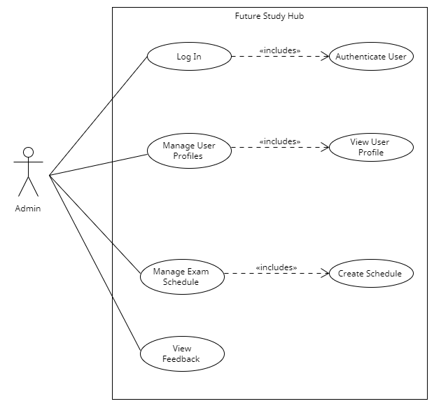

Figure 1: UCD for Admin

* Teacher: -

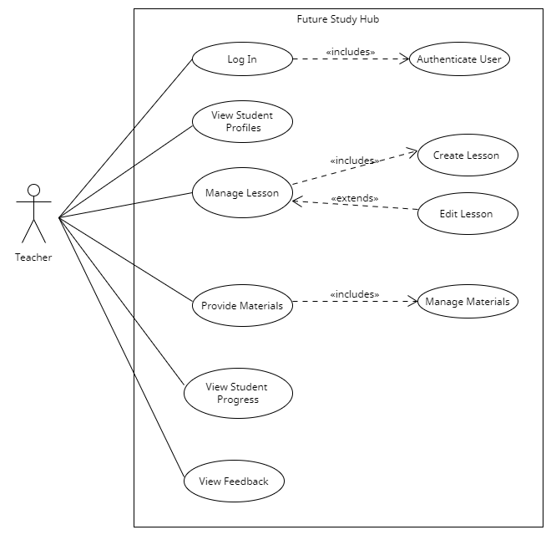

Figure 2: UCD for Teacher

* Student: -

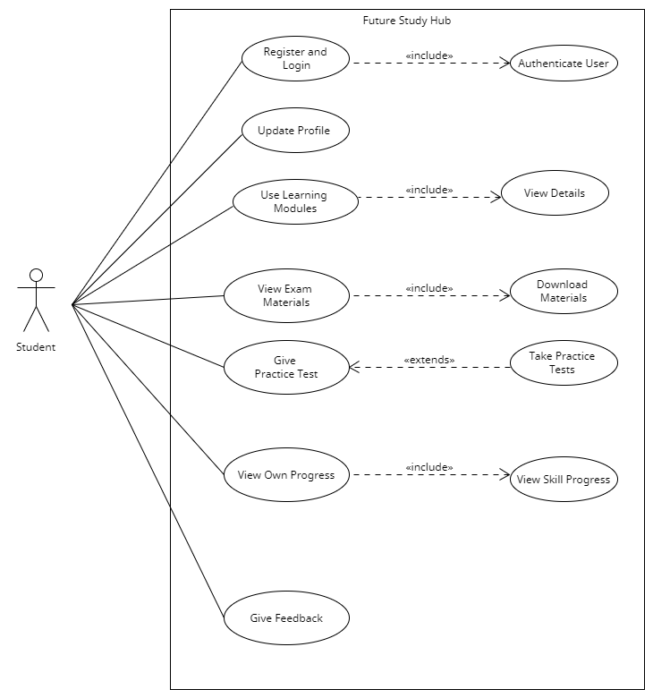

Figure 3: UCD for Student

## Activity Diagram: -

* Login :-

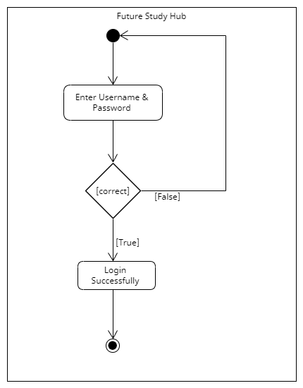

Figure 4: AD for Login

* Registration:-

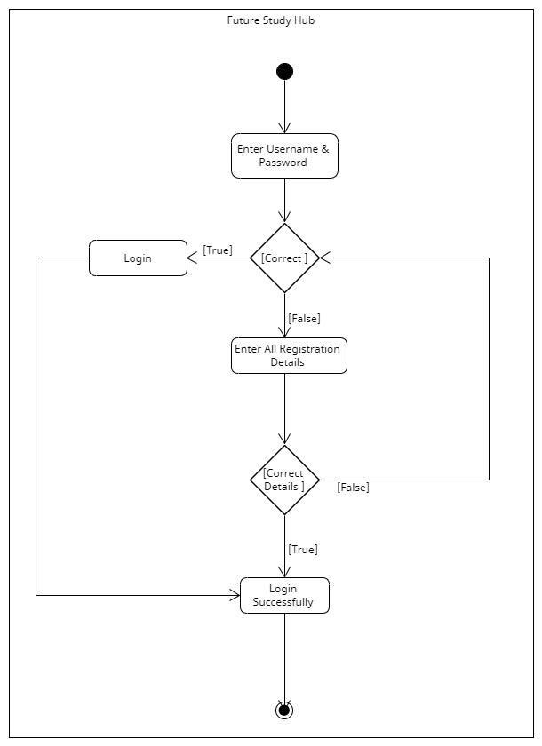

Figure 4: AD for Registration

# System Model: -

## Prototyping Model Implementation for Our Project: -

1. **Model Overview: -**In the context of "Future Study Hub," a prototyping system model can be defined as a preliminary version or mock-up of the actual system, aimed at validating key functionalities, user interactions, and design aspects before proceeding to full-scale development. The prototyping system model serves as a visual representation or simulation of the final system, allowing stakeholders to provide feedback, identify potential issues, and refine requirements early in the development process.
2. **Reason: -**
3. **Basic Functionality Representation: -**The prototyping system model includes essential functionalities such as user registration, login, profile management, access to study materials, practice tests, feedback submission, and progress tracking. These functionalities provide a foundation for user interactions and system navigation.
4. **User Interface Design: -**The prototype features a user-friendly interface with navigation controls, input fields, buttons, and interactive elements resembling the final system's design. It focuses on usability, simplicity, and intuitiveness to enhance user experience.
5. **Limited Functionality Implementation: -**While the prototype demonstrates core functionalities, it may not fully implement backend processes or database interactions. Instead, it utilizes simulated data or simplified algorithms to mimic system behaviour and responses.
6. **Rapid Iterative Development: -**The prototyping system model follows an iterative development approach, allowing for quick modifications, additions, or refinements based on stakeholder feedback. It facilitates agile development practices and fosters collaboration between developers, designers, and end-users.
7. **Feedback Collection Mechanism: -**The prototype includes mechanisms for collecting user feedback, comments, and suggestions during usability testing sessions or demonstrations. This feedback is crucial for identifying usability issues, improving user flows, and validating system requirements.

# Database Design: -

## Table with description includes attributes, data type, size, and constraints: -

**Admin Table**

|  |  |  |  |  |
| --- | --- | --- | --- | --- |
| **Field Name** | **Data Type** | **Constraints** | **Description** | **Example Values** |
| admin_id | INT | Not Null, Primary Key | Unique identifier for admin | 1 |
| admin_name | VARCHAR(30) | Not Null | Name of the admin | "Admin123" |
| email | VARCHAR(30) | Not Null | Email address of the admin | [admin@example.com](mailto:admin@example.com) |
| password | VARCHAR(15) | Not Null | Password of the admin | Admin@123 |

**Module Table**

|  |  |  |  |  |
| --- | --- | --- | --- | --- |
| **Field Name** | **Data Type** | **Constraints** | **Description** | **Example Values** |
| module_id | INT | Not Null, Primary Key | Unique identifier for Module | 1 |
| module_name | VARCHAR(10) | Not Null | Name of the Module | General |
| description | VARCHAR(255) |  | Description of the Module | General module for normal English |

**Teacher Table**

|  |  |  |  |  |
| --- | --- | --- | --- | --- |
| **Field Name** | **Data Type** | **Constraints** | **Description** | **Example Values** |
| teacher_id | INT | Not Null, Primary Key | Unique identifier for each Teacher | 1 |
| teacher_name | VARCHAR(30) | Not Null | Name of the Teacher | "Sujal hirpara" |
| email | VARCHAR(50) | Not Null | Email address of the Teacher | [sujal12@gmail.com](mailto:sujal12@gmail.com) |
| contact No | INT | Not Null | Contact no of Teacher | 9807654321 |
| gender | VARCHAR(10) | Not Null | Gender of Teacher | Male |
| dob | DATE | Not Null | birth date of Teacher | 25-03-1995 |
| validation | VARCHAR(255) | Not Null | photo of degree validation | Degree photo |
| password | VARCHAR(30) | Not Null | Password of the Teacher | Student@123 |
| module_id | INT | Foreign Key | Foreign key referencing the Module table | 1 |
| hire_date | DateTime |  | Date of teacher's hiring | 1/15/2023 |

**Subject Table**

|  |  |  |  |  |
| --- | --- | --- | --- | --- |
| **Field Name** | **Data Type** | **Constraints** | **Description** | **Example Values** |
| sub_id | INT | Not Null, Primary Key | Unique identifier for each Subject | 1 |
| sub_name | VARCHAR(10) | Not Null | Name of the Subject | Reading |
| module_id | INT | Foreign Key | Foreign key referencing the Module table | 1 |
| description | VARCHAR(255) |  | Description of the Subject | Reading in English study in this subject |

**Student Table**

|  |  |  |  |  |
| --- | --- | --- | --- | --- |
| **Field Name** | **Data Type** | **Constraints** | **Description** | **Example Values** |
| student_id | INT | Not Null, Primary Key | Unique identifier for each student | 1 |
| student_name | VARCHAR(30) | Not Null | Name of the student | "Preet vachhani" |
| email | VARCHAR(50) | Not Null | Email address of the student | [preet12@gmail.comm](mailto:preet12@gmail.comm) |
| gender | VARCHAR(10) | Not Null | Gender of Teacher | Male |
| contact No | INT | Not Null | Contact no of Students | 9087654321 |
| dob | DATE | Not Null | birth date of Student | 26-05-2005 |
| validation | VARCHAR(255) | Not Null | photo of adhar card or any age validation | Aadhar card photo |
| password | VARCHAR(30) | Not Null | Password of the Student | Student@123 |
| enrollment_date | DateTime |  | Date of enrolment | 1/15/2023 |

**Exam Table**

|  |  |  |  |  |
| --- | --- | --- | --- | --- |
| **Field Name** | **Data Type** | **Constraints** | **Description** | **Example Values** |
| exam_id | INT | Not Null, Primary Key | Unique identifier for each exam | 1 |
| exam_name | VARCHAR(30) | Not Null | Name of the exam | "Final Exam" |
| exam_date | DateTime | Not Null | Date of the exam | 12/02/2024 :: 12:20:30 |
| total_marks | INT | Not Null | Total marks of exam | 50 |
| passing_marks | INT |  | Passing marks of exam | 25 |
| description | VARCHAR(255) |  | Description of the Exam | Chapter 1, tpoic 1 exaam |
| student_id | INT | Foreign Key | Foreign key referencing the Student table | 1 |
| sub_id | INT | Foreign Key | Foreign key referencing the Sub-Subject table | 1 |

**Material Table**

|  |  |  |  |  |
| --- | --- | --- | --- | --- |
| **Field Name** | **Data Type** | **Constraints** | **Description** | **Example Values** |
| material_id | INT | Not Null, Primary Key | Unique identifier for each Material | 1 |
| material_name | VARCHAR(100) | Not Null | Name of the Material | Chapter 1 Slides, "Lab Manual" |
| description | VARCHAR(255) |  | Description of the material | Presentation slides for Chapter 1 |
| sub_id | INT | Foreign Key | Foreign key referencing the Sub-Subject table | 1 |

**Feedback Table**

|  |  |  |  |  |
| --- | --- | --- | --- | --- |
| **Field Name** | **Data Type** | **Constraints** | **Description** | **Example Values** |
| feedback_id | INT | Not Null, Primary Key | Unique identifier for each feedback | 1 |
| student_id | INT | Foreign Key | Foreign key referencing the student table | 1 |
| teacher_id | INT | Foreign Key | Foreign key referencing the Teacher table | 1 |
| feedback_text | VARCHAR(255) |  | Textual feedback provided by the student | Great teacher! |
| feedback_date | Date |  | Date when the feedback was submitted | 21-03-2022 |

**Payment Table**

|  |  |  |  |  |
| --- | --- | --- | --- | --- |
| **Field Name** | **Data Type** | **Constraints** | **Description** | **Example Values** |
| payment_id | INT | Not Null, Primary Key | Unique identifier for each payment | 101 |
| student_id | INT | Foreign Key | Foreign key referencing the student table | 1 |
| amount | DOUBLE | Not Null | Amounts of Payment | ₹ 1,000.00 |
| payment_date | DATETIME |  | Date and Time of the Payment | 24-03-2023 |
| method | VARCHAR(100) |  | Payment methods (e.g., Credit card, PayPal) | GooglePay(UPI) |
| status | VARCHAR(10) |  | Status of the payment (e.g., Paid, Pending) | SUCCESSFULL |

## A normal form of a database schema: -

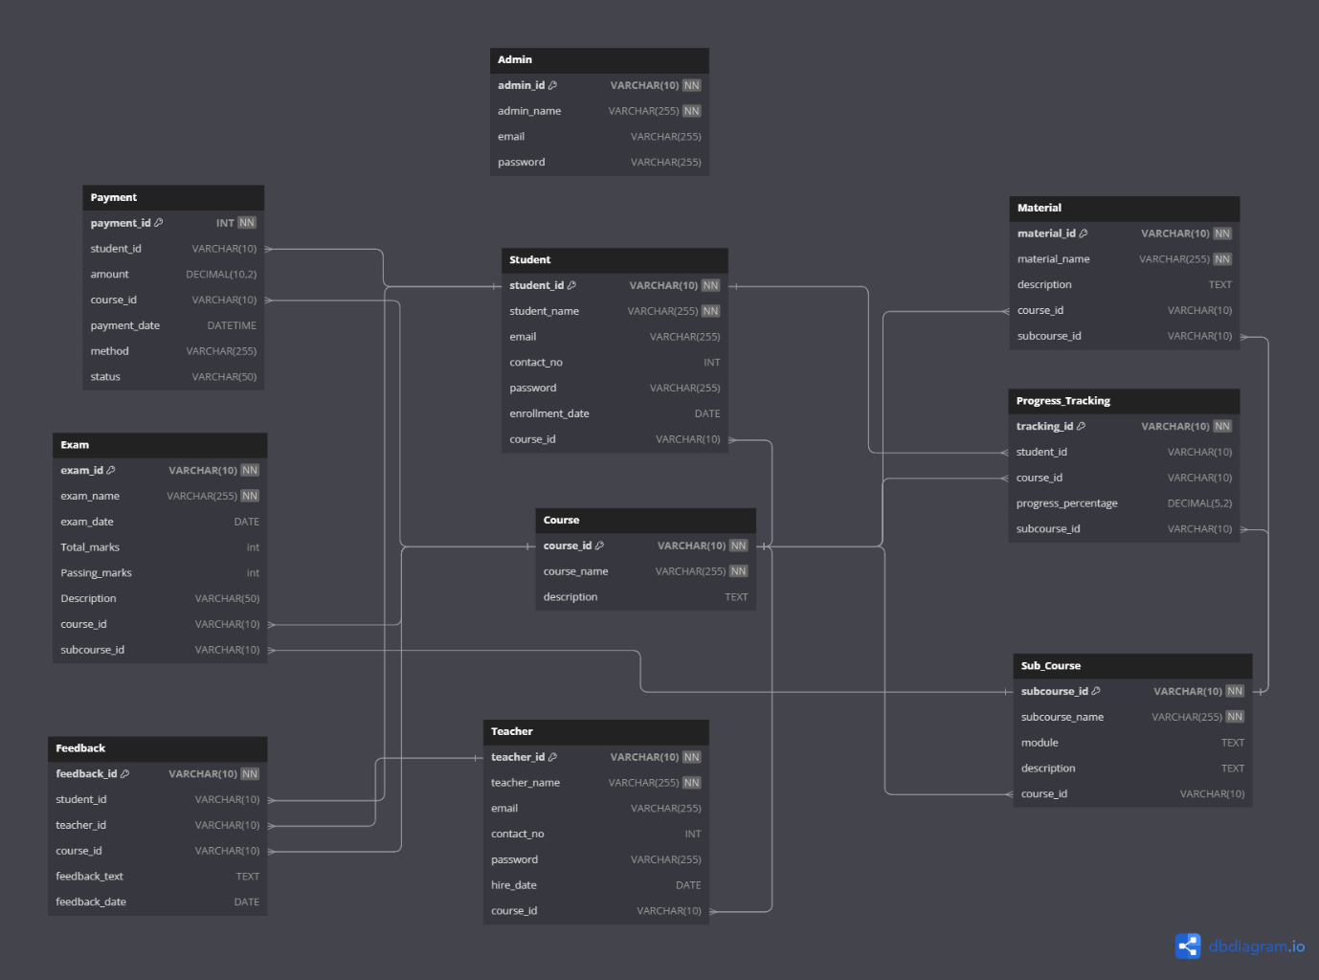

Figure 6: DATABASE Schema

## Number of tables: -

* Total 10 Tables

# User Interface Design

## Screenshot of Homepage: -



Figure 7: Home Page

### Used navigation control with justification: -The navigation bar at the top of the page helps users interact with the website more easily. It has links to important sections like "Home," "Meeting," "Apply Now," "Pages," "Courses," and "Contact us." This makes it quick and simple for users to move around the website and find information they need. The navigation bar makes it easier for users to use the website and find what they're looking for.

## Screenshot of UI: -

1. **Sign Up Page: -**

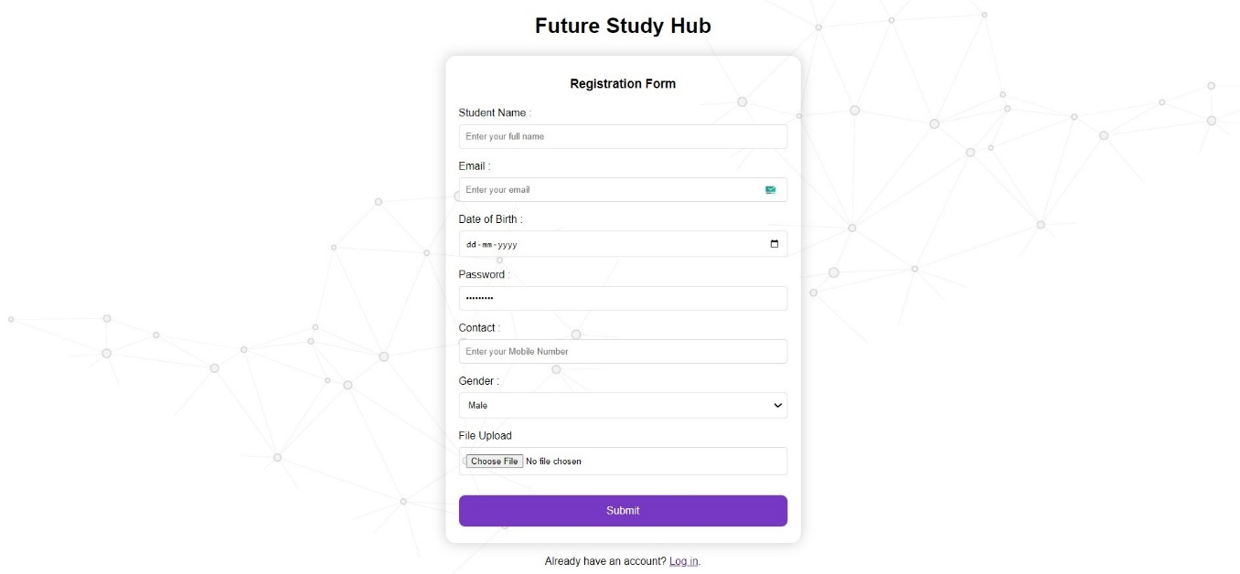

Figure 8: Sign Up Page

* **Purpose of the UI: -**The purpose of the signup page for Future Study Hub is to collect essential user information, such as name, email, password, phone number, to create a new user account and enable access to the system services.
* **Used control with justification: -**
* **Text Input Fields (User Name, Email, Password, Phone No): -** These blank spaces are where you type in important information like your name, email, and password. They are important because we need this data to set up your account.
* **"Sign Up" Button:** When you click on this button, it's like saying, "I'm ready!" It's the start button for signing up.
* **Login Here Link:** If you already have an account, you can click on this to go to the login page. It's a way for people who are already members to get back in.

1. **Login Page: -**

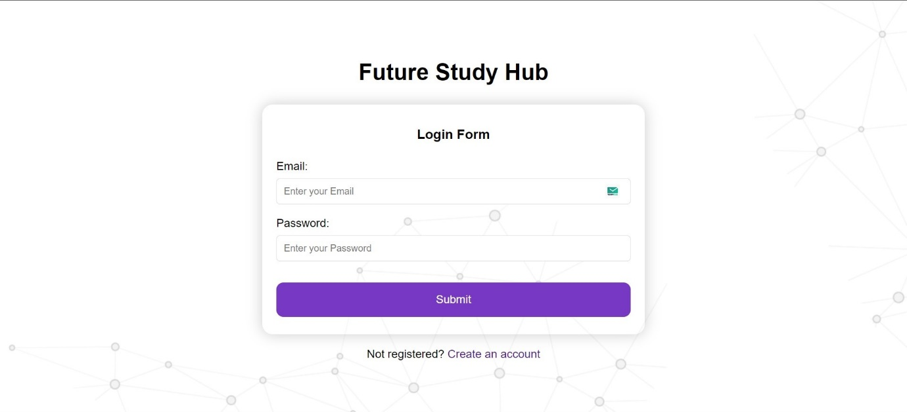

Figure 9: Login Page

* **Purpose of the UI: -** The purpose of the login page for Future Study Hub is to allow users to access their accounts by entering their email address and password, while the "Forgot Password" feature is designed to help users reset their forgotten passwords and regain access to their accounts.
* **Used control with justification: -**
* **Email and Password Fields: -** These are where users type in their email and password. They're important because we need this information to let users log in.
* **Login Button:** When users click this button, it's like saying, "I'm ready to log in." It's important because it starts the login process once they've entered their email and password.

1. **Course : -**

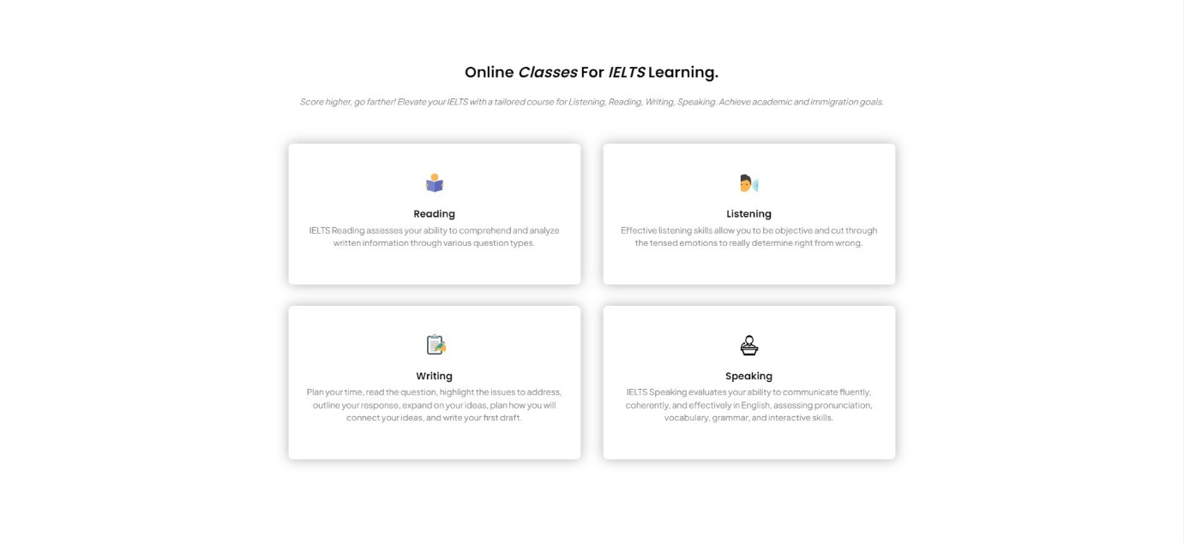

Figure 10: Courses

# Report Design: -

## TPS Report: -

**Date: -** 11/03/2024

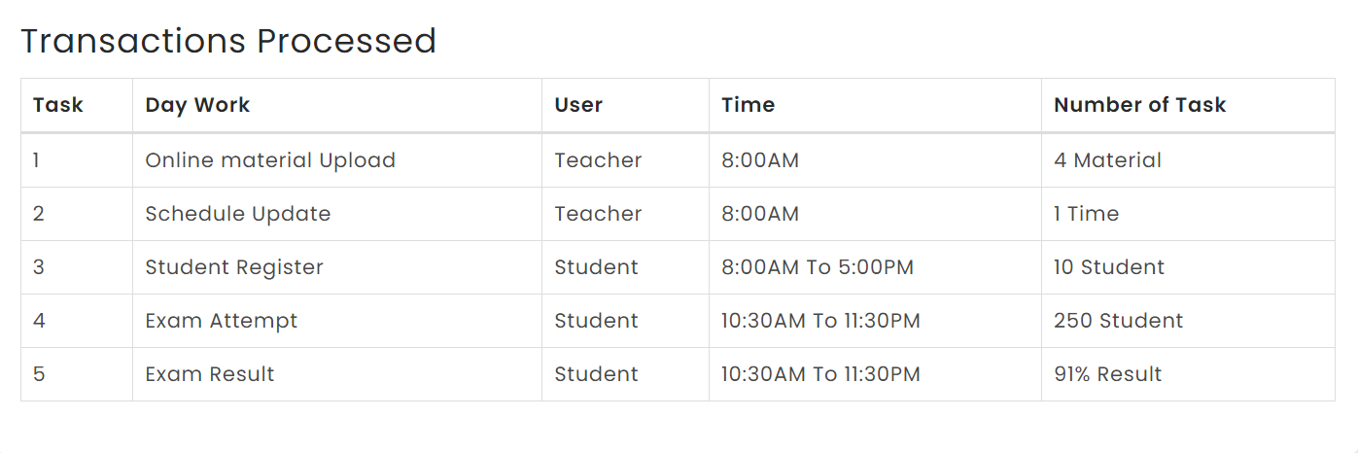

Figure 11: TPS Report

## MIS Report: -

**Student Registration**

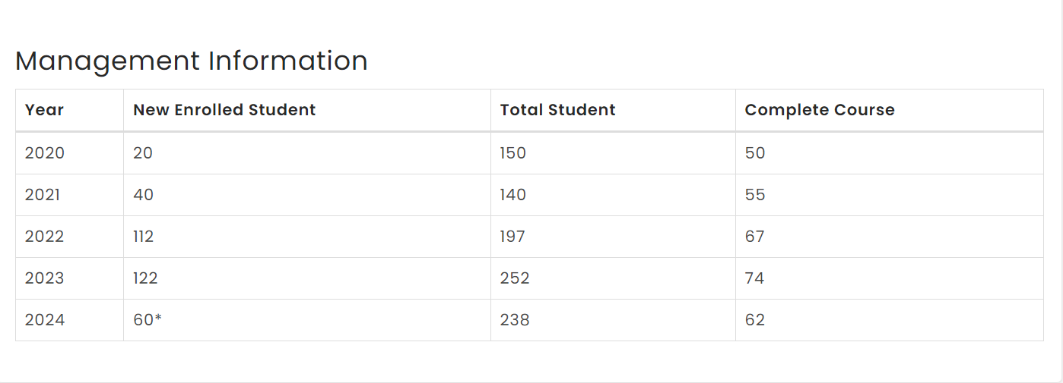

Figure 12: MIS Report

## Dashboard: -

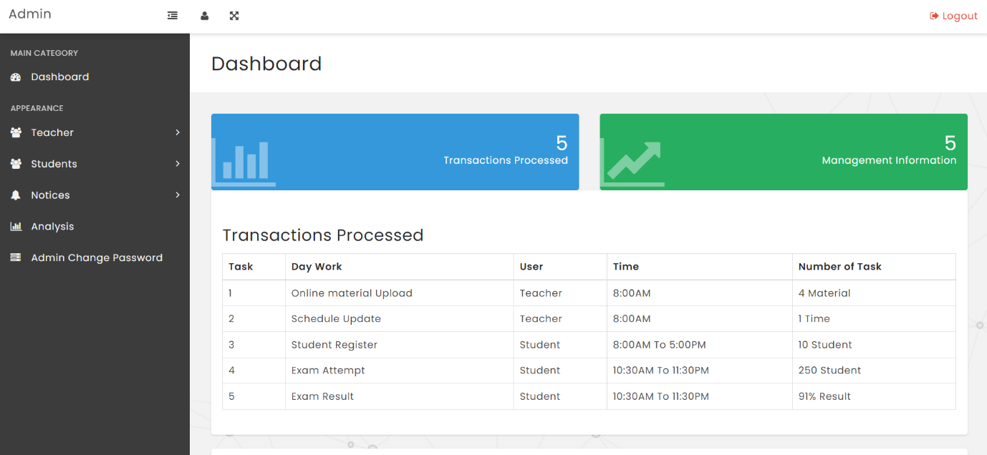

Figure 13: Dashboard